|  |  |
| --- | --- |
| Name : John Philip G. Cauilan | Section : BSIT 3A |
| Assignment No : 3 | Submission Date : April 6, 2024 |
| Assignment Title: Guessing Number Game | |

**Code :**

**HTML FILE**

*<!DOCTYPE html>*

*<html lang="en">*

*<head>*

*<meta charset="UTF-8" />*

*<meta name="viewport" content="width=device-width, initial-scale=1.0" />*

*<title>Number Guessing Game</title>*

*<link rel="stylesheet" href="gues.css" />*

*</head>*

*<body>*

*<div class="container">*

*<h1>Guessing Number Game</h1>*

*<p>*

*Guess a number between 1 and 10. You have 5 attempts to guess the correct number.*

*</p>*

*<input type="text" id="userGuess" />*

*<button onclick="checkGuess()">*

*Submit*

*</button>*

*<p id="message"></p>*

*<p id="attempts"></p>*

*</div>*

*<script src="gues.js"></script>*

*</body>*

*</html>*

**JS FILE**

*const randomNumber = Math.floor(Math.random() * 10) + 1;*

*let attempts = 0;*

*function checkGuess() {*

*const userGuess = parseInt(document.getElementById("userGuess").value);*

*const messageElement = document.getElementById("message");*

*const attemptsElement = document.getElementById("attempts");*

*if (isNaN(userGuess) || userGuess < 1 || userGuess > 10) {*

*messageElement.textContent = "Invalid input: Please input a number between 1 and 10.";*

*return;*

*}*

*attempts++;*

*attemptsElement.textContent = `Attempts: ${attempts}/5`;*

*if (userGuess < randomNumber) {*

*messageElement.textContent = "Too low! Try again.";*

*} else if (userGuess > randomNumber) {*

*messageElement.textContent = "Too high! Try again.";*

*} else {*

*messageElement.textContent = `Congratulations! You've guessed the correct number (${randomNumber}) in ${attempts} attempts.`;*

*restartGame();*

*}*

*if (attempts >= 5) {*

*messageElement.textContent = `Game over: You've reached the maximum number of attempts (${attempts}). The correct number was ${randomNumber}.`;*

*restartGame();*

*}}*

*function restartGame() {*

*attempts = 0;*

*randomNumber = Math.floor(Math.random() * 10) + 1;*

*document.getElementById("userGuess").value = "";*

*messageElement.textContent = "Take a guess!";*

*attemptsElement.textContent = "Attempts: 0/5";*

*}*

**CSS FILE**

*body {*

*font-family: Helvetica, sans-serif;*

*display: flex;*

*justify-content: center;*

*align-items: center;*

*height: 100vh;*

*margin: 0;*

*padding: 0;*

*background-color: #f5f5f5;*

*}*

*.container {*

*text-align: center;*

*margin: 0;*

*padding: 0;*

*background-color: #fff;*

*border-radius: 10px;*

*box-shadow: 0 0 10px rgba(0, 0, 0, 0.1);*

*padding: 50px;*

*}*

*input[type="text"] {*

*padding: 10px;*

*box-sizing: border-box;*

*border-radius: 5px;*

*border: 1px solid #ccc;*

*width: 50%;*

*font-size: 1.2rem;*

*}*

*button {*

*padding: 10px 20px;*

*margin-top: 10px;*

*background-color: #4CAF50;*

*color: white;*

*border: none;*

*cursor: pointer;*

*border-radius: 5px;*

*transition: background-color 0.3s;*

*}*

*button:hover {*

*background-color: #45a049;*

*}*

*#message {*

*margin-top: 20px;*

*font-size: 1.2rem;*

*}*

*#attempts {*

*margin-top: 10px;*

*font-size: 1.2rem;*

*}*

**SCREENSHOT**

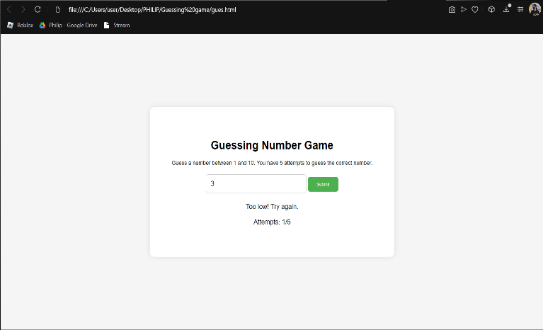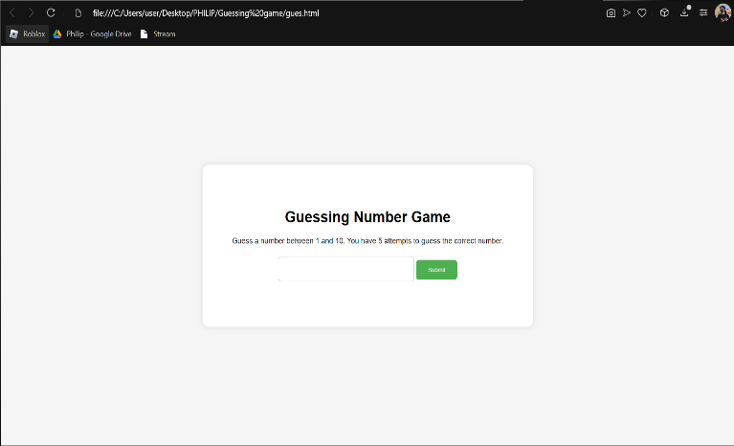

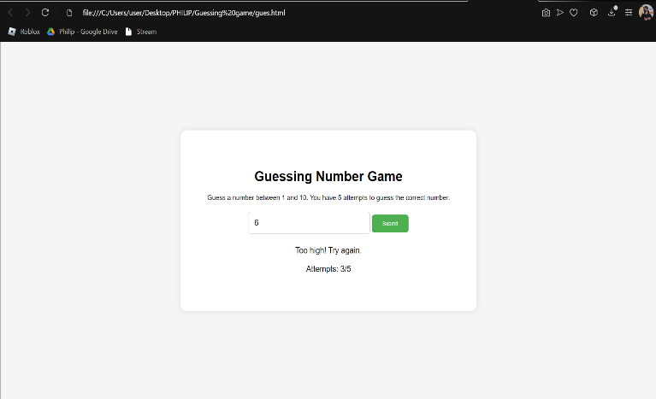

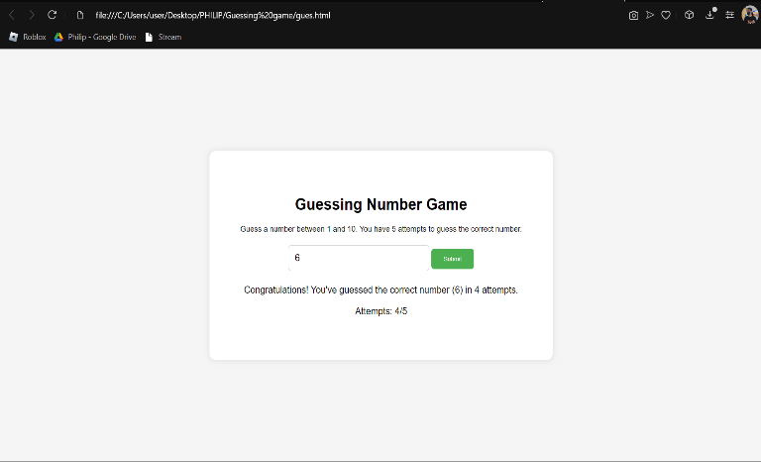

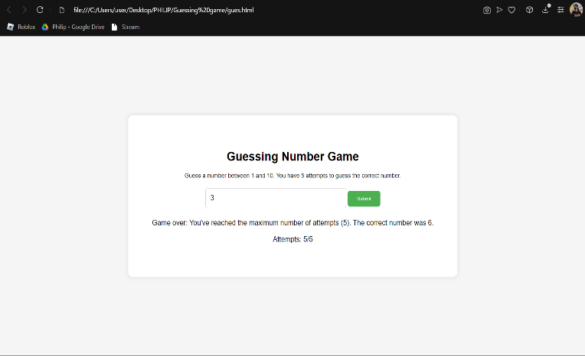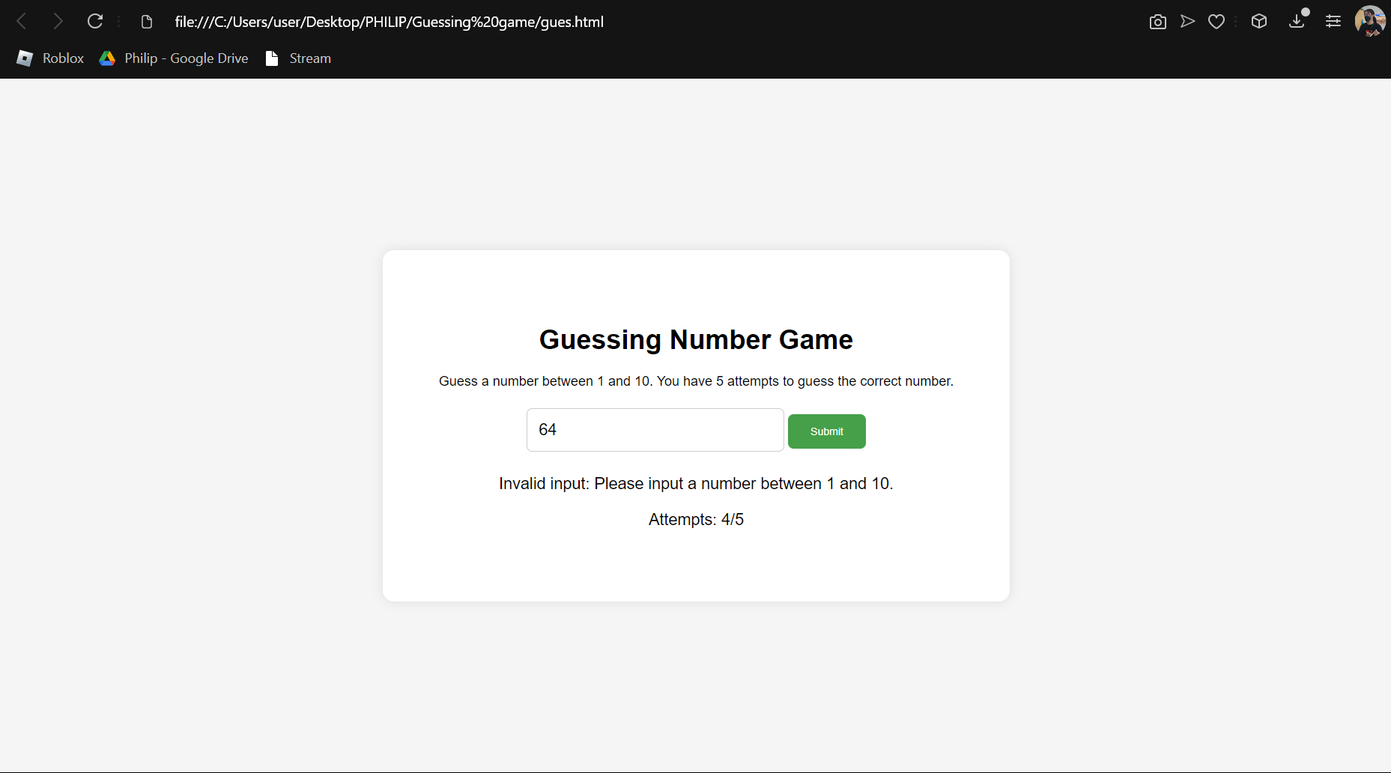

**Dictionary:**

*// List keywords, tags, or methods that are new to you and explain how they are used in the code.*

*// atleast 5 tag, methods or keyword*

* **Math.random()**: This method returns a floating-point, pseudo-random number between 0 (inclusive) and 1 (exclusive). In this code, it is used to generate a random number for the guessing game

**Syntax**: Math.random() * 10

* **Math.floor()**: This method rounds down a number to the nearest integer. In this code, it is used in conjunction with Math.random() to generate a random integer between 1 and 10.

**Syntax**: Math.floor(Math.random() * 10);

**Parameter**: const randomNumber = Math.floor(Math.random() * 10) + 1;

* **const**: This is a keyword used to declare a variable with a constant value. In this code, it is used to declare variables that are not intended to be reassigned, such as randomNumber and attempts.

**Syntax**: const Class_Name Object_name;

**Parameter**: const randomNumber = Math.floor(Math.random() * 10) + 1;

let attempts = 0;

function checkGuess() {

const userGuess = parseInt(document.getElementById("userGuess").value);

const messageElement = document.getElementById("message");

const attemptsElement = document.getElementById("attempts");

// ...

}

function restartGame() {

attempts = 0;

randomNumber = Math.floor(Math.random() * 10) + 1;

// ...

}

* **onclick**: This is an event attribute that attaches a click event to an HTML element. In this code, it is used to attach the checkGuess() function to the button element.

**Syntax**: < button onclick="myFunction()">

**Parameter**: <button onclick="checkGuess()">Submit</button>

* **parseInt()**: This method converts a string or a number into an integer. In this code, it is used to convert the user's input (which is a string) into an integer for comparison with the random number.

**Syntax**: Number. parseInt(string, radix)

**Parameter**: const userGuess = parseInt(document.getElementById("userGuess").value);